NAME ____________________________________________

CS 420/520 Theory of Computation, Spring 2019 at Indiana State University, taught by Jeff Kinne
Quiz 7 / Exam 1 - regular languages

Points - each part is graded as 1 point, half credit is possible. Total # points = 10

1) For each of these, if the following language is regular, give an RE, DFA, or NFA for the language. If it is not regular, prove it is not regular using the pumping lemma. SKIP ONE.

1a.
L = {strings of a's and b's without three b's in a row}
In the language: empty string, aabab, bbabbab, ababa, aaa
Not in the language: bbb, abbababbbaab

1b.
L = {strings of a's and b's with more b's than a's}
In the language: bba, abb, bbaababab
Not in the language: bbaa, aaa, a, aba

1c.
L = {strings of a's and b's that do not contain the string abb}
In the language: abab, ab, a, b, bbab, abaab
Not in the language: babb, ababba, babba, baabba

1d.
L = {strings of 0's and 1's that cannot be written as www,
that is - first third = middle third = last third}
In the language: 010100, 010010011, 00, 010, 10101
Not in the language: 010010010

2) For each of the following, give a Python3 regular expression for the given
language. Include the begin and end marker symbols. SKIP ONE.

2a. Integers
In the language: 0001, 1010101, 1341343, -123, -0, 0
Not in the language: 1.2, pi, -,

2b. Fractions
In the language: 1/2, 3/4, 0/4, -1/3, 234234/2342334
Not in the language: 1.2, pi, -, 4/0, 234/, 2/-3, 234

2c. Sentence of the form - "What is your name? NAME. Hello NAME."
Note - NAME can be any combination of letters, first letter upper case and the rest lower.
Note – you should match “What is your name?” and “Hello “ literally – don’t make up RE’s for sentences like that, just match those exact sentences.

3) Prove by induction or contradiction. SKIP ONE.

3a. The cube root of 7 is irrational.

3b. 1/2 + 1/(2*3) + 1/(3*4) + ... + 1/(n*(n+1)) = n/(n+1)

3c. For all integers k, if k*k is even then k is even.

4) Write a table for the transition function of the following NFA or DFA. Let the third state have the label “c”, so the set of states is Q = {a, b, c}
https://www.tutorialspoint.com/automata_theory/images/dfa_graphical_representation.jpg
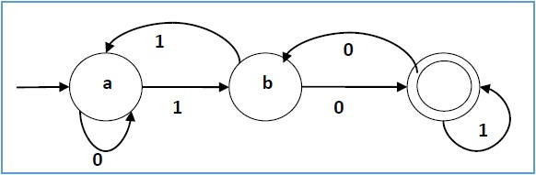

5) Describe the language accepted by the following NFA or DFA.
https://cdncontribute.geeksforgeeks.org/wp-content/uploads/either01nfa-1.png
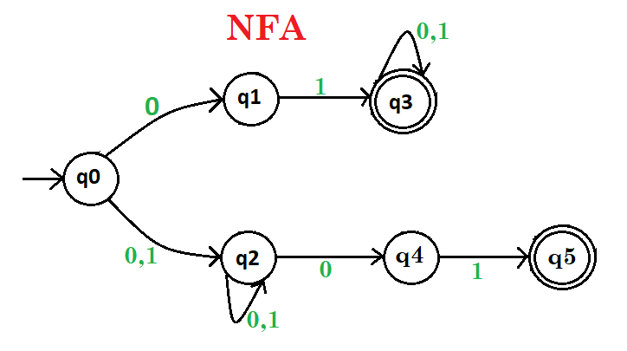

6) Prove the following. The class of regular languages is closed under
intersection.

